**CAP782: RESPONSIVE WEB DESIGN**

**CONTINUOUS ASSESSMENTS (C.A)-2**

**ST_NAME : - EKHLAKH AHMAD**

**REG NO. : - 12209166**

**ROLL NO. : - 68**

**GROUP : - 2**

**OUTPUT**

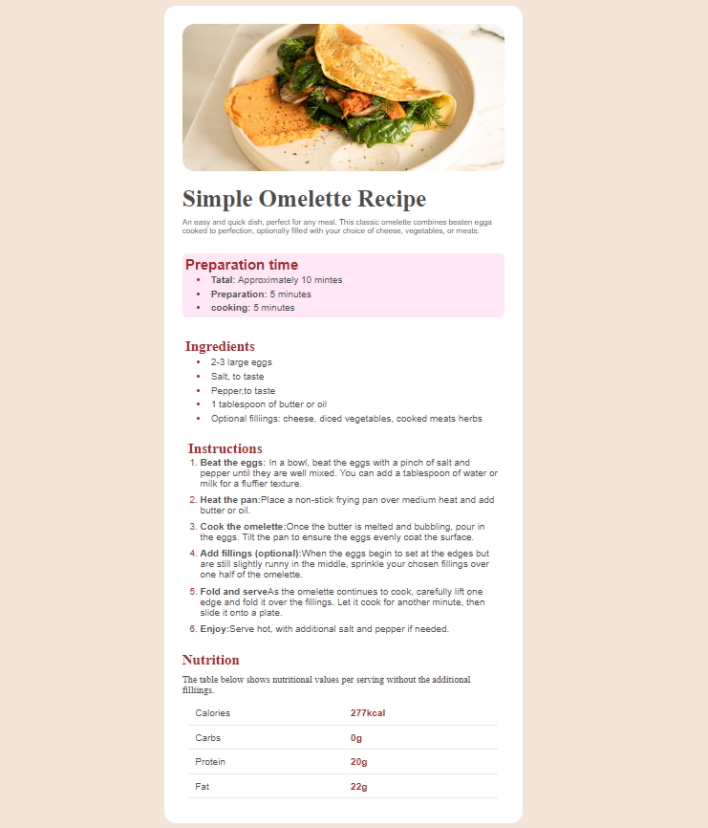

**HTML CODE**

<!DOCTYPE html>

<html lang="en">

<head>

    <meta charset="UTF-8">

    <meta name="viewport" content="width=device-width, initial-scale=1.0">

    <title>CA-2</title>

    <link rel="stylesheet" href="style.css">

</head>

<body>

    <div class="container">

        <header>

            <img src="./images/image-omelette.jpeg" alt="image">

        </header>

        <div class="hero">

            <h1>Simple Omelette Recipe</h1>

        <p>An easy and quick dish, perfect for any meal. This classic omelette combines beaten egga cooked to perfection, optionally filled with your choice of cheese, vegetables, or meats.</p>

        </div>

        <div class="prepartion">

            <h2>Preparation time</h2>

            <ul>

                <li><span>Tatal:</span> Approximately 10 mintes</li>

                <li><span>Preparation:</span> 5 minutes</li>

                <li><span>cooking:</span> 5 minutes</li>

            </ul>

        </div>

        <div class="inter">

            <h2>Ingredients</h2>

            <ul>

                <li>2-3 large eggs</li>

                <li>Salt, to taste</li>

                <li>Pepper,to taste</li>

                <li>1 tablespoon of butter or oil</li>

                <li>Optional filliings: cheese, diced vegetables, cooked meats herbs</li>

            </ul>

        </div>

        <div class="intructions">

            <h2>

                Instructions

            </h2>

            <ol>

                <li><span>Beat the eggs: </span>In a bowl, beat the eggs with a pinch of salt and pepper until they are well mixed. You can add a tablespoon of water or milk for a fluffier texture. </li>

                <li><span>Heat the pan:</span>Place a non-stick frying pan over medium heat and add butter or oil.</li>

                <li><span>Cook the omelette:</span>Once the butter is melted and bubbling, pour in the eggs. Tilt the pan to ensure the eggs evenly coat the surface. </li>

                <li><span>Add fillings (optional):</span>When the eggs begin to set at the edges but are still slightly runny in the middle, sprinkle your chosen fillings over one half of the omelette. </li>

                <li><span>Fold and serve</span>As the omelette continues to cook, carefully lift one edge and fold it over the fillings. Let it cook for another minute, then slide it onto a plate.</li>

                <li><span>Enjoy:</span>Serve hot, with additional salt and pepper if needed. </li>

            </ol>

        </div>

        <div class="nutrition">

            <h2>Nutrition</h2>

            <p>The table below shows nutritional values per serving without the additional filliings.</p>

            <table>

                <tr>

                    <td>Calories</td>

                    <td><span>277kcal</span></td>

                </tr>

                <tr>

                    <td>Carbs</td>

                    <td><span>0g</span></td>

                </tr>

                <tr>

                    <td>Protein</td>

                    <td><span>20g</span></td>

                </tr>

                <tr>

                    <td>Fat</td>

                    <td><span>22g</span></td>

                </tr>

            </table>

        </div>

    </div>

</body>

</html>

**CSS CODE**

*{

    margin: 0;

    padding: 0;

    box-sizing: *border-box*;

    color: rgb(77, 75, 75);

}

body{

    background-color: #f3e5d8;

}

.container{

    width: 600px;

    height: *auto*;

    margin: 50px *auto*;

    padding: 30px;

    background-color: *white*;

    border-radius: 20px;

    display: *flex*;

    flex-direction: *column*;

    flex-wrap: *wrap*;

    gap: 10px;

}

.hero{

    display: *flex*;

    flex-direction: *column*;

    flex-wrap: *wrap*;

}

.hero p{

    font-family: *sans-serif*;

    font-size: 13px;

}

h1{

    margin-block: 10px;

    font-size: 40px;

}

header img{

    width: 100%;

    border-radius: 20px;

}

.prepartion{

    padding: 5px;

    border-radius: 8px;

    margin-block: 20px;

    background-color: #ffabe049;

    font-family: *sans-serif*;

}

li::marker{

    color: *brown*;

}

.prepartion h2{

    color: *brown*;

}

.prepartion ul {

    padding-left: 40px;

}

.prepartion ul li{

    padding: 3px;

    border-radius: 10px;

}

.prepartion span{

    font-weight: *bold*;

}

.inter{

    padding: 5px;

}

.inter h2{

    color: *brown*;

}

.inter ul {

    padding-left: 40px;

    font-family: *sans-serif*;

}

.inter ul li{

    padding: 3px;

}

.intructions{

    padding: 10px;

}

.intructions ol{

    font-family: *sans-serif*;

    padding-left: 20px;

}

.intructions ol li{

    margin-bottom: 10px;

}

.intructions span{

    font-weight: *bold*;

}

.intructions h2{

    color: *brown*;

}

.nutrition h2{

    color: *brown*;

    margin-bottom: 10px;

}

.nutrition table{

    font-family: *sans-serif*;

    width: 100%;

    padding: 10px;

}

.nutrition table td{

    border-bottom: 0.1px *solid* #e7e6e6;

    padding: 10px;

}

.nutrition table span{

    color: *brown*;

    font-weight: *bold*;

}